**Ideation Phase**

**Brainstorm & Idea Prioritization Template**

**Step-1: Team Gathering, Collaboration and Select the Problem Statement**

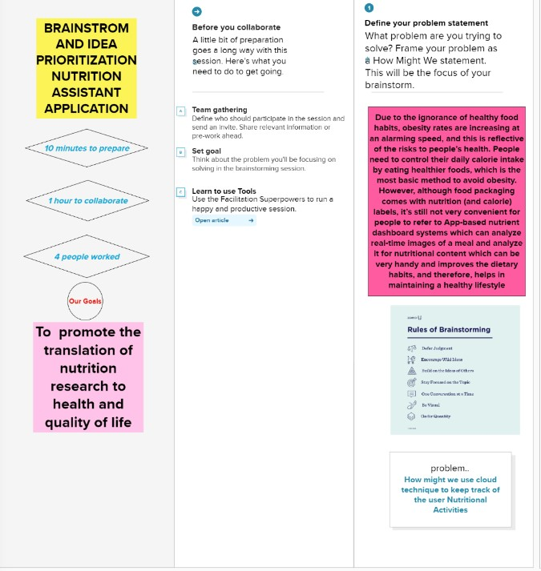

# Step-2: Brainstorm, Idea Listing and Grouping

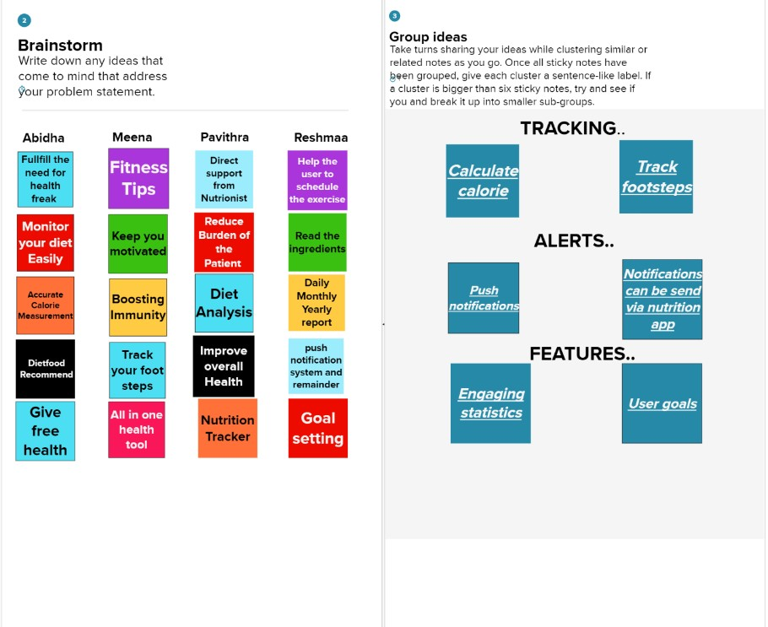

# Step-3: Idea Prioritization

